NOTICE OF MEETING OF THE

COMMISSIONERS COURT OF FRIO COUNTY, TEXAS

Notice is hereby given that a Special Called Meeting of the above-named Commissioners Court will be held on the **29th**day of **August, 2022**, at **3:00 p.m**., in the Frio County Courtroom, Pearsall, Texas, and also via video conference with a link provided at <http://www.co.frio.tx.us/>. It is the intent of the Frio County Commissioners Court that a quorum of the court and the presiding member of the court will be present at the above-mentioned location and time. Court members may be participating via videoconference pursuant to Tex. Gov’t Code § 551.127. Interested citizens may participate in person at the courthouse, but due to the COVID-19 pandemic, citizens are encouraged to instead participate by accessing the weblink found on the above-mentioned address. During the meeting, the following subjects will be discussed, to-wit:

I. Invocation and Pledge of Allegiance

II. Adopt Agenda

**Move Action Agenda Item #24 to #2**

**Motion by: Commissioner Carrizales**

**Seconded by: Commissioner Graf**

**Motion Carried**

III. Old Business

**PRESENTATION**

**ACTION AGENDA ITEMS**

IV. General Discussion

V. Citizens To Be Heard

*Please note that the Rules of Procedure, Conduct and Decorum at Meetings of the Commissioners Court of Frio County, Texas limit each speaker to a maximum of three (3) minutes to make his or her remarks. Inappropriate conduct or comments during this time, including but not limited to disruptive behavior, insults, personal attacks, and inappropriate language, may result in the speaker being ordered to leave the meeting and forfeit any remaining speaking time. For more information regarding the above-mentioned rules, please see the complete Rules of Procedure, Conduct and Decorum at Meetings of the Commissioners Court of Frio County, Texas, which is available upon request.*

VI. New Business

**PRESENTATION**

(1) Hon. Aaron Ibarra, Frio County Clerk, requests:

Presentation to show new updates made to the County Clerk’s Office in regards to online birth certificates and accessibility.

(2) Hon. Raul Carrizales, III. Frio County Commissioner, Precinct No. 3, requests:

Presentation of monthly statistics reports compiled by Allegiance.

**ACTION AGENDA ITEMS**

(1) Placido Aguilar, City of Pearsall Volunteer Fire Department, requests:

Consider/take action on waiving the rental fees for the use of Fireman’s Park to host National Night Out on Tuesday, October 4, 2022

**Motion by: Commissioner Graf**

**Seconded by: Commissioner Vela**

**Motion Carried – Commissioner Carrizales Abstained**

(2) Hon. Crystal Marquez, Frio County Auditor, requests:

Consider / take action on selecting a telephone systems / internet services provider from the bids received.

**Spectrum Chosen**

**Motion by: Commissioner Carrizales**

**Seconded by: Commissioner Graf**

**Motion Carried**

(3) Hon. Crystal Marquez, Frio County Auditor, requests:

Consider / take action on selecting a ground Emergency Medical Services provider from the bids received.

**SureMed Chosen**

**Motion by: Commissioner Carrizales**

**Seconded by: Commissioner Graf**

**Motion Carried**

(4) Hon. Mike Morse, Frio County Sheriff, requests:

4.1 Consider/take action on approving a Quote and Standard Terms and Conditions with LumenServe for a Frio County Tower Lighting Upgrade at a rate of $365.00 per month.

**Motion by: Commissioner Graf**

**Seconded by: Commissioner Carrizales**

**Motion Carried**

4.2 If the agreement is approved, then sign a resolution authorizing Frio County Judge Arnulfo C. Luna to enter into said contract on behalf of Frio County.

(5) Hon. Mike Morse, Frio County Sheriff, requests:

5.1 Consider/take action on approving Contract for Providing Health Care Services for the Frio County Jail with ReadyCare-Dilley, Inc. for a monthly fee of $4,000.00.

**Motion by: Commissioner Carrizales**

**Seconded by: Commissioner Graf**

**Motion Carried**

5.2 If the contract is approved, then approve and sign a resolution authorizing Frio County Judge Arnulfo C. Luna to execute the Agreement on behalf of Frio County.

(6) Hon. Mike Morse, Frio County Sheriff, requests:

Consider / take action on running a sealed request for proposals (RFP) ad (below) in the Frio Nueces Current once a week for two weeks pursuant to Local Government Code Sec. 262.025.  The ad will run in the Frio-Nueces Current on September 1, 2022, September 8, 2022, and on September 15, 2022.  Sealed RFP’s will be accepted in the Auditor’s office until 3:00 pm, September 22, 2022.  RFP’s will be opened during commissioner’s court on September 26, 2022.

**Bid Notice**

By order of the Commissioner’s Court of Frio County, Texas, and pursuant to Section 262.023 of the Texas Local Government Code, sealed requests forinmate meal supplies and services to meet all Texas Jail Standards requirements for a 96-bed housing population. Services shall include, a menu certified by a licensed dietician, supplying of all needed tools to implement a meal program, on sight training for all assigned staff including training for grocery ordering, food preparation, portion control, invoice preparation, and inventory reports.

The Frio County Jail is located at 502 S. Cedar St. in Pearsall, Texas. All bids will be received at the Frio County Auditor’s office, 500 E San Antonio Street, Pearsall, Texas 78061 until September 22, 2022 at 3:00pm. Bids received after the time indicated will be returned unopened. The bids will be opened and read aloud during the Commissioner’s Court meeting on September 26, 2022 at 3:00pm. Prospective bidders may contact Chief Deputy Pedro Salinas, 502 S. Cedar Street, Pearsall, Texas 78061; phone 830-334-3311, or by e-mail psalinas@friosheriff.org in regards to obtaining biding/proposal information. Bidder should use unit pricing and include any delivery costs. The County of Frio reserves the right to reject any and all Bids and to accept the Bid most advantageous to the County.

**Motion by: Commissioner Graf**

**Seconded by: Commissioner Vela**

**Motion Carried**

(7) Hon. Arnulfo C. Luna, Frio County Judge, requests:

Consider/take action on approving County Choice Silver for Retirees of Frio County for this coming Budget year 2022-2023.  If approved Frio County would pay 100% for the following 3 years for qualified retirees.

**Motion by: Judge Luna**

**Seconded by: Commissioner Carrizales**

**Motion Carried**

(8) Hon. Arnulfo C. Luna, Frio County Judge, requests:

Discuss, consider and act on allowing the use of an amount not to exceed $3000 from the ARPA funds for elderly/disable or indigent families which may be used as vouchers during the Farmers Market Day on Oct. 6, 2022.

**Motion by: Commissioner Asuncion**

**Seconded by: Commissioner Carrizales**

**Motion Carried**

(9) Hon. Hon. Arnulfo C. Luna, Frio County Judge, requests:

Consider/take action on making a donation to the Community Council of South Central Texas’, Inc. Reserve Fund

**Motion by: Commissioner Carrizales**

**Seconded by: Commissioner Asuncion**

**Motion Carried**

(10) Aaron Ibarra, Frio County Clerk, requests:

10.1 Review and consider for action the adoption of a County Clerk Records

Archive fee - $10.00 -Gov. Code 51.305(b) County Clerk Records Technology Fund

**Motion by: Commissioner Carrizales**

**Seconded by: Commissioner Vela**

**Motion Carried**

10.2 Consider/take action on setting a public hearing date for the adoption of the County Court Record Archive Plan.

**Date Set- 09/26/2022**

(11) Hon. Ofilia M. Trevino, Frio County District Clerk, requests:

11.1 Consider/take action on adoption of a District Court Record Archive Fee - $10.00 pursuant to Texas Government Code 51.305(b) for the District Court Records Technology Fund.

**Motion by: Commissioner Carrizales**

**Seconded by: Commissioner Vela**

**Motion Carried**

11.2 Consider/take action on setting a public hearing date for the adoption of the District Court Record Archive Plan.

**Date Set- 09/26/2022**

(12) Roxanna Garcia, Frio County Engineer, requests:

Approve and execute the donation letter between Frio County and XTO Energy Permian/South Texas Business Unit for 20 loads (approximately 500 tons) of flexible base to restore and maintain CR 3715/Schorp Road.

**Motion by: Commissioner Graf**

**Seconded by: Commissioner Vela**

**Motion Carried**

(13) Roxanna Garcia, Frio County Engineer, requests:

Discussion and update Commissioners Court on the progress of the surveying project for the eastside of Derby, Texas.

**Item Discussed**

(14) Roxanna Garcia, Frio County Engineer, requests:

Open bids received by the specified deadline for the Bridge Repair Project located at CR 1301/Yancey Rd. over Tehuacana Creek and take action on selecting a bid or rejecting all bids.

**Roxanna to Review**

(15) Roxana Garcia, Frio County Engineer, requests:

Consider / take action on running a sealed request for proposals (RFP) ad (below) in the Frio Nueces Current once a week for two weeks pursuant to Local Government Code Sec. 262.025.  The ad will run in the Frio-Nueces Current on September 1, 2022, September 8, 2022, and on September 15, 2022.  Sealed RFP’s will be accepted in the Auditor’s office until 3:00 pm, September 22, 2022.  RFP’s will be opened during commissioner’s court on September 26, 2022.

**Motion by: Commissioner Graf**

**Seconded by: Commissioner Carrizales**

**Motion Carried**

**BID NOTICE**

By order of the Commissioner’s Court of Frio County, Texas, and pursuant to Section 262.023 of the Texas Local Government Code, sealed requests for bids for the Bridge and Approach Replacement Project for bridges located on CR 2410/ San Miguel Rd. and CR 3314/ E. Goldfinch Rd., will be received at the Frio County Auditor’s Office located at 500 E. San Antonio, Pearsall, Texas 78061 until **3:00 P.M., September 22, 2022**. Bids received after the time indicated will be returned unopened. The bids will be opened and read aloud during the Commissioner’s Court meeting on **September 26, 2022**. Prospective bidders may contact Roxana Garcia, P.E. at 2207 BL 35 E, Pearsall, Texas 78061; phone 830-334-0085; or by e-mail at [Roxana.Garcia@friocounty.org](mailto:Roxana.Garcia@friocounty.org) in regards to obtaining bidding documents. An appointment to inspect the project may be scheduled by contacting Ms. Garcia. Frio County reserves the right to reject any and all bids and to accept the bid most advantageous to the County. For more information, visit <http://www.co.frio.tx.us/>.

(16) Hon. Crystal Marquez, Frio County Auditor, requests:

16.1 Consider / take action to approve the budget amendments to the FISCAL YEAR 2021-2022 Frio County Budget, list below:

**Motion by: Commissioner Carrizales**

**Seconded by: Commissioner Asuncion**

**Motion Carried**

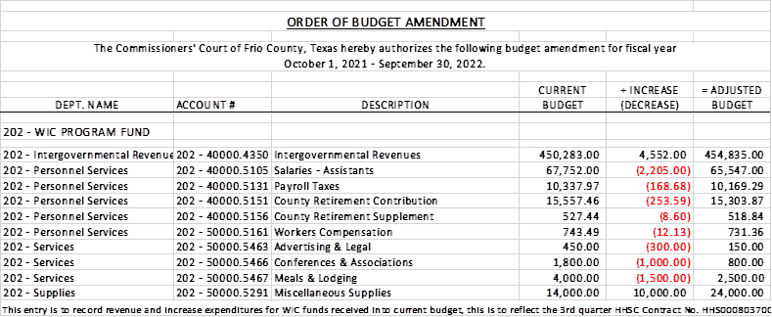

16.2 If the amendment is approved, consider/take action on signing order stating same.

(17) Hon. Crystal Marquez, Frio County Auditor, requests:

17.1 Consider / take action to approve the budget amendments to the FISCAL YEAR 2021-2022 Frio County Budget, list below:

**Motion by: Commissioner Graf**

**Seconded by: Commissioner Vela**

**Motion Carried**

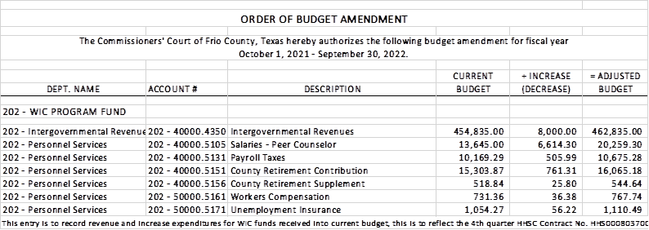

17.2 If the amendment is approved, consider/take action on signing order stating same.

(18) Hon. Crystal Marquez, Frio County Auditor, requests:

18.1 Consider / take action to approve the budget amendments to the FISCAL YEAR 2021-2022 Frio County Budget, list below:

**Motion by: Commissioner Graf**

**Seconded by: Commissioner Carrizales**

**Motion Carried**

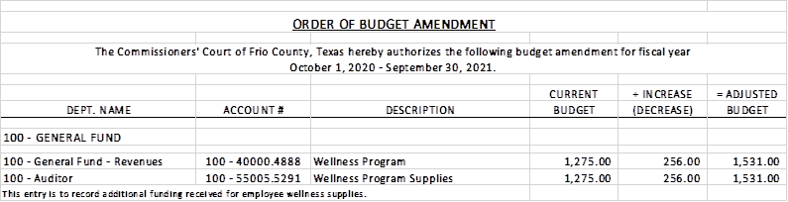

18.2 If the amendment is approved, consider/take action on signing order stating same.

(19) Hon. Crystal Marquez, Frio County Auditor, requests:

19.1 Consider / take action to approve the budget amendments to the FISCAL YEAR 2021-2022 Frio County Budget, list below:

**Motion by: Commissioner Carrizales**

**Seconded by: Commissioner Graf**

**Motion Carried**

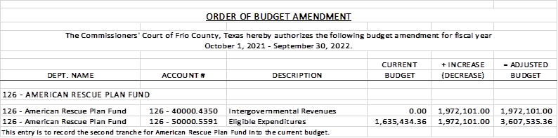

19.2 If the amendment is approved, consider/take action on signing order stating same.

(20) Hon. Crystal Marquez, Frio County Auditor, requests:

20.1 Consider / take action on approving change order number 2 from Boxx Modular for additional 7’ length and 4’ width ramp needed to meet slope of site to the original 4x30 ramp to follow ADA compliance, for a total cost of $980.00.

20.2 If approved consider / take action on using ARP eligible expenses to issue payment for the change order number 2 from Boxx Modular.

**Motion by: Commissioner Graf**

**Seconded by: Commissioner Carrizales**

**Motion Carried**

(21) Hon. Crystal Marquez, Frio County Auditor, requests:

Consider / take action to approve additional water delivery cost of $6,595.00 delivered to Derby, Texas, to be covered by ARP eligible expenses.

**Motion by: Commissioner Carrizales**

**Seconded by: Commissioner Vela**

**Motion Carried**

(22) Hon. Crystal Marquez, Frio County Auditor, requests:

Consider / take action to approve the 2022-2023 Proposed Tax Rate:

**Proposed Tax Rate: = $0.596800/$100**

No-New-Revenue Tax Rate: = $0.541881/$100

Voter-Approval Tax Rate: = $0.661423/$100

De Minimis Rate: = $0.566297/$100

**Motion by: Commissioner Graf**

**Seconded by: Commissioner Carrizales**

**Motion Carried**

Note: The public hearing on the proposed tax rate and voting on the proposed tax rate will be on Monday, September 12, 2022 at 3:00pm in the Frio County Courthouse.  Notices will run in the Frio Nueces Current on Thursday, September 01, 2022.

(23) Hon. Raul Carrizales, III. Frio County Commissioner, Precinct No. 3, requests:

Discussion regarding Frio County Emergency Warning System to include Pearsall, Dilley and unincorporated areas.

**Item Discussed**

(24) Hon. Raul Carrizales, III. Frio County Commissioner, Precinct No. 3, requests:

Discuss and Action on approving a resolution for Flood Mitigation Grants services with the Nueces River Authority.

**Motion by: Commissioner Carrizales**

**Seconded by: Commissioner Asuncion**

**Motion Carried**

(25) Hon. Crystal Marquez, Frio County Auditor, requests:

Consider / take action on approving using ARP eligible expenses for electrical services needed at the modular building for the estimated cost of $8,000, the project will be completed by Joe Perez.

**Motion by: Commissioner Carrizales**

**Seconded by: Commissioner Vela**

**Motion Carried**

(26) Hon. Crystal Marquez, Frio County Auditor, requests:

Consider / take action on approving using ARP eligible expenses for plumbing and trenching services needed at the modular building, for the estimated cost of $10,000, the project will be completed by DPS Plumbing.

**Motion by: Commissioner Asuncion**

**Seconded by: Commissioner Carrizales**

**Motion Carried**

(27) Hon. Crystal Marquez, Frio County Auditor, requests:

27.1 Consider / take action to approve the budget amendments to the FISCAL YEAR 2021-2022 Frio County Budget, list below:

**Motion by: Commissioner Graf**

**Seconded by: Commissioner Carrizales**

**Motion Carried- Commissioner Asuncion Opposed**

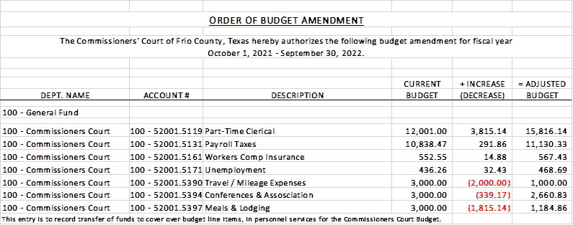

27.2 If the amendment is approved, consider/take action on signing order stating same.

(28) Documents (resolutions, orders, contracts, etc.) to be signed.

(29) Allow bills payable

**Motion by: Commissioner Carrizales**

**Seconded by: Commissioner Graf**

**Motion Carried**

(30) Adjourn

**Motion by: Commissioner Carrizales**

**Seconded by: Commissioner Asuncion**

**Motion Carried**

**THE FRIO COUNTY COURTHOUSE IS WHEELCHAIR ACCESSIBLE AND HANDICAP PARKING IS AVAILABLE. ANY REQUEST FOR SIGN INTERPRETIVE SERVICES MUST BE MADE 48 HOURS PRIOR TO THE MEETING. TO MAKE ARRANGEMENTS, PLEASE CALL (830) 334-2154.**

**THE FRIO COUNTY COMMISSIONERS COURT RESERVES THE RIGHT TO CONVENE INTO CLOSED (EXECUTIVE SESSION) UNDER V.T.C.A., GOVERNMENT CODE, CHAPTER 551, SUBCHAPTER D; SECTION 551.071, FOR PURPOSE OF CONSULTING WITH ITS ATTORNEYS; SECTION 551.072, DELIBERATING ABOUT REAL PROPERTY; SECTION 551.073, DELIBERATING ABOUT GIFTS, AND DONATIONS; SECTION 551.074, DELIBERATING ABOUT PERSONNEL MATTERS; SECTION 551.076, DELIBERATING ABOUT SECURITY DEVICES; SECTION 551.084, REGARDING EXCLUSION OF WITNESS FROM HEARING IN CONNECTION WITH AN INVESTIGATION; SECTION 551.086, DELIBERATING, VOTING, AND TAKING ACTION AS A POWER UTILITY ON A COMPETITIVE MATTER; SECTION 551.087, DELIBERATING ABOUT ECONOMIC DEVELOPMENT NEGOTIATIONS; AND SECTION 551.088, DELIBERATING ABOUT TEST ITEMS TO DISCUSS AND/OR DELIBERATE ANY OF THE POSTED MATTERS TO BE CONSIDERED DURING THE OPEN MEETING AND, IF IT DOES SO AFTER TAKING A VOTE IN OPEN SESSION, IT WILL THEN GO INTO CLOSED (EXECUTIVE) SESSION, DELIBERATE, THEN RECONVENE IN OPEN SESSION, VOTE ON ANY DECISION TAKEN, AND ANNOUNCE SAME FOR THE COMMISSIONERS COURT’S MINUTES.**

Dated this the 26th of August, 2022.

_________________________________________

Hon. Arnulfo C. Luna

Frio County Judge

I, the undersigned, County Clerk, do hereby certify that the above Notice of Meeting of the above-named Commissioners’ Court, is a true and correct copy of said Notice on the bulletin board at the Courthouse door of Frio County, Texas at a place readily accessible to the general public at all times on the **26th** day of **August,** **2022** and said Notice remained so posted continuously for at least 72 hours preceding the scheduled time of said Meeting.

Dated this the 26th day of August, 2022.

COUNTY CLERK, FRIO COUNTY, TEXAS

BY_____________________________________